* Design TM using simulator to accept the input string anb2n

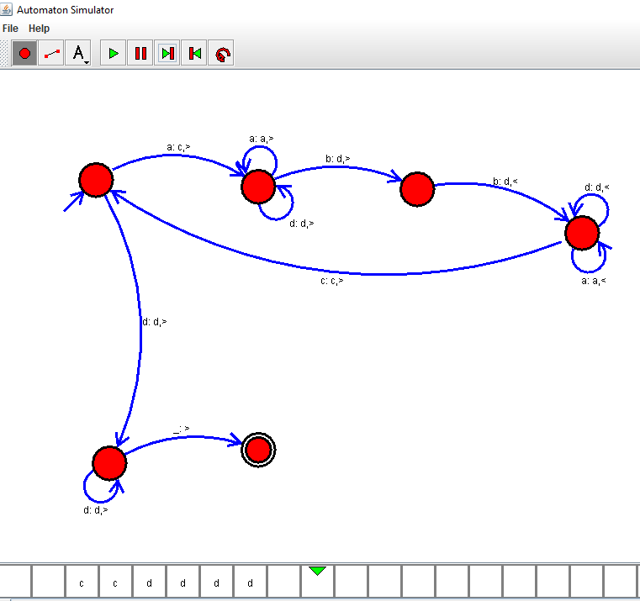

Result :

The simulator is accepted the input string anb2n by using the above TM diagram